DURATION: 2 Hours

THEORIC CONTENTS

* Lesson 2. Algorithms.
* Lesson 3. Data Types.
* Lesson 4. Operators and Expressions.
* Lesson 5. Input and Output.

LEARNING OBJECTIVES

* **LO-02.1.** Identify the Variables that are required in algorithm design.
* **LO-02.2.** Identify the Constants that are required in algorithm design.
* **LO-03.1.** Choose correctly the data type of a variable according to the values that it could store in algorithm design.
* **LO-03.2.** Choose correctly the data type of a constant according to the values that it could store in algorithm design.
* **LO-05.1.** Implement variables in C language in function of the type and range of values that is needed in the design of a given algorithm.

GITHUB CLASSROOM ASSIGNMENT

**https://classroom.github.com/a/c3-n2dSB**

PROPOSED EXERCISES

Exercise 1. Design and implement a C program that solves the next problem definition:

The program has to ask the following data of a student:

* Name. It can be a composed name (ex. “Jose Damian”).
* First Surname. It can be a composed name (ex. “de la Rosa”).
* DNI. Including the number and the letter. (ex. 67859402N).
* Date of birth. It has to be composed by three number which corresponds to the day, month and year respectively. (ex. “01 12 2009”).
* Gender. The valid values only are ‘M’ for Male or ‘F’ for female.

Once all data have been entered, the program should write the student data in the file "result.txt"

**Example:** The following figure shows the content the file "result.txt" should have once the program has finished.

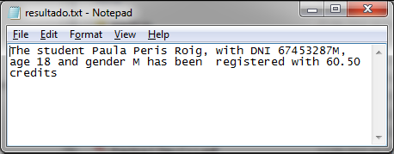

*Exercise 2.* Design and implement a C program that solves the next problem definition:

Computes the square of an integer number, which must be read from data.txt. The result should be written to the file result.txt.

NOTE. Before to execute the program, you have to create “data.txt” file using Notepad program.

**Example:**

Input File (Data.txt) Output File (result.txt)

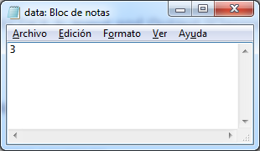 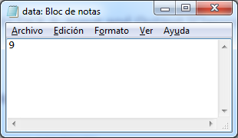

*Exercise 3.* Design and implement a C program that solves the next problem definition:

Consider the following table as the list of products that are served at a bar, with their corresponding prices.

|  |  |  |
| --- | --- | --- |
| |  | | --- | | **Sandwich/Roll** | | **Price** |
| Sausage | 1.10 |
| Tuna | 1.40 |
| **Drinks** |  |
| Water | 0.50 |
| Coca Cola | 0.75 |
| Orange Juice | 0.70 |

Write a program that asks the user how much has consumed of each product. Once, all the data have been entered, the program should display the total bill corresponding to the user and should receive how much has paid the user.

Next, the screen should be cleared with system**("cls")** of **stdlib.h** and the following messages should be displayed:

**NOTE:** Prices must be declared as CONSTANTS.

xx sandwiches of sausage at xx.xx euros are xxx.xx euros

xx sandwiches of tuna at xx.xx euros are xxx.xx euros

xx bottles of water at xx.xx euros are xxx.xx euros

xx bottles of coca cola at xx.xx euros are xxx.xx euros

xx glasses of orange juice at xx.xx euros are xxx.xx euros

-----------------------------------------

TOTAL: xxx.xx euros

Payment: xxx.xx euros

Refund: xxx.xx euros

Example:

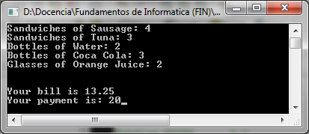

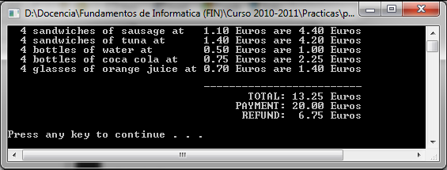

|  |  |
| --- | --- |
|  |  |

|  |  |
| --- | --- |
|  |  |

*Exercise 4*. Design and implement a C program that solves the next problem definition:

A car parts company needs a program that computes and displays the selling price (Euros) of its products. In this sense, the program should apply the following formula:

|  |  |
| --- | --- |
| $$profit=costprice*\frac{margin}{100}$$ $$sellingprice=costprice+profit$$ |  |
|  | |

The cost price and the profit margin are specified in a file, whose name must be given by the user. The program should read such values and then, it should compute the selling price. The result should be displayed on the screen and added to the input file.

**Note:** the file that stores the cost Price and the profit margin must exist before the program runs.

Example:

Input File: Output File:

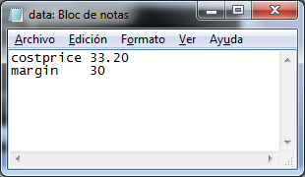 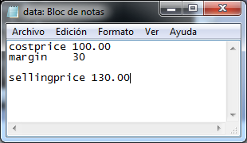

*Exercise* 5. Design and implement a C program that solves the next problem definition:

The program has to copy each line of the file “info.txt” to “info2.txt”, considering that each line in the destination file must be preceded by the line number. Consider the origin file has 3 lines.

Example:



|  |  |
| --- | --- |
|  |  |